2023 – 2025 Ashland County Community Health Improvement Plan (CHIP)
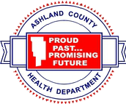
Table of Contents

Executive Summary
At a Glance
Community Health
Improvement Process
Prioritization
Prioritized Health Needs
Next Steps & Conclusion
Acknowledgements
Work Plan

Executive Summary

In 2022, the Ashland County Health Department, in collaboration with the University Hospitals Samaritan Medical Center, and other key partners within the county, conducted a comprehensive Community Health Assessment (CHA). This assessment, referred to as the 2022 Ashland County CHNA, was conducted in compliance with the requirements set forth by the Treasury Regulation §1.501(r) and the Ohio Revised Code
§3701.981.

The 2022 Ashland County Community Health Needs Assessment served as a foundation for the development of a collaborative Community Health Improvement Plan (CHIP) and Implementation Strategy (IS) aimed at addressing the identified health needs of the community. These needs include those that the collaborative determines it is able to meet in whole or in part, are in line with its mission, and are not currently being met or are not adequately met by other programs and services within the service area.

Similar to the Community Health Needs Assessments (CHNA) that collaborative members are required to conduct, completing a CHNA and corresponding CHIP/IS are integral components of the process that local and state health departments must undertake in order to continue accreditation through the Public Health Accreditation Board (PHAB). The 2022 Ashland County CHNA satisfies the requirements for PHAB accreditation and will be used as a guide for developing a comprehensive plan to improve the health of the community.

The Ashland County CHIP/IS aims to address the most pressing health concerns facing our community. These include cancer, access to healthcare, mental health, and substance use/misuse. The plan focuses on identifying and addressing the root causes of these issues in order to improve the overall health and well- being of Ashland County residents. The plan is a collaborative effort and the community's participation, and support is crucial to its success.

Through this effort, the University Hospitals Samaritan Center, the Ashland County Health Department, and other partners in the county aim to improve the overall health and well-being of the residents in Ashland County. By working together and addressing the root causes of the identified health needs, we can create a healthier and more equitable community for all.

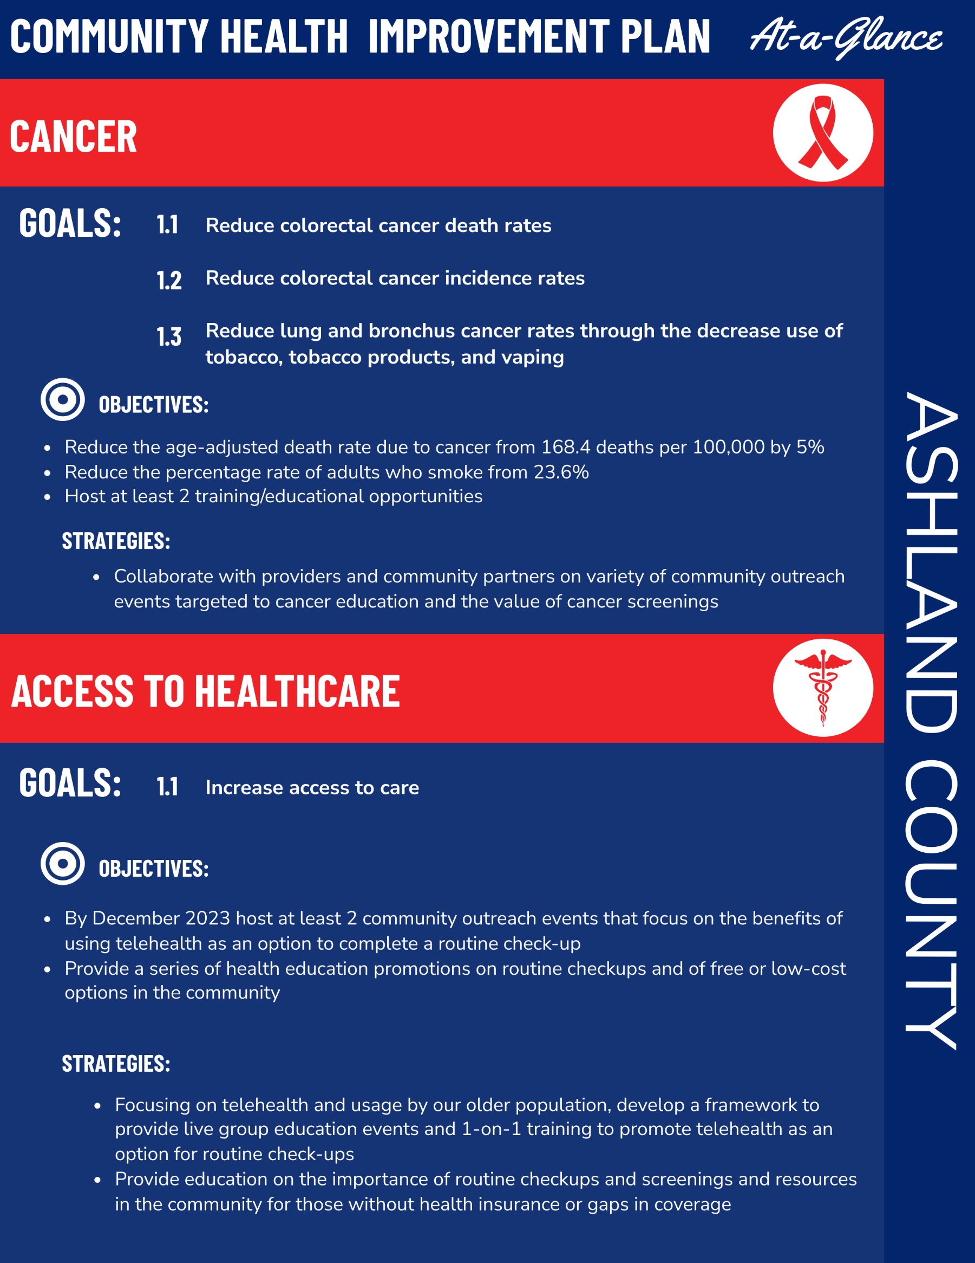

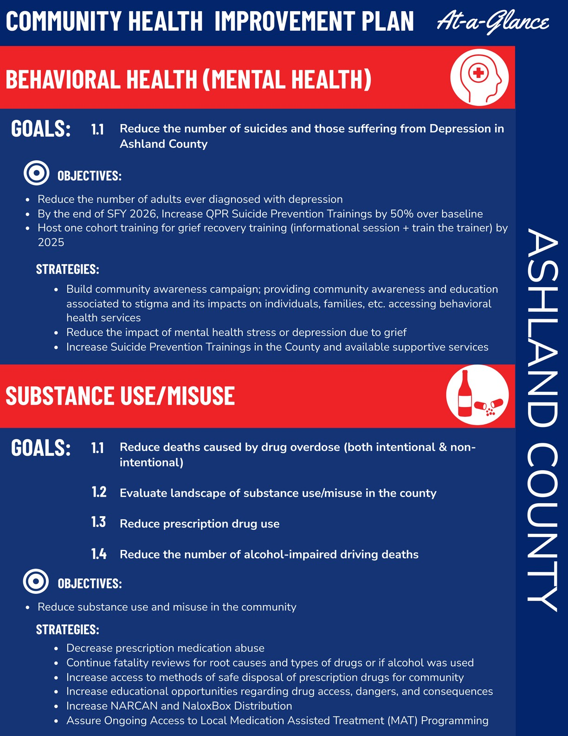

Community Health Improvement Process

State of Ohio Requirements
In 2016, Ohio law required tax-exempt hospitals to partner with local health departments on community health assessments and improvement plans to reduce resource duplication and improve overall community health. These assessments and plans must align with the state's own assessment and improvement plan. One example of this partnership is the collaboration between the Ashland County Health Department, University Hospitals Samaritan Medical Center, and the community to create a unified community health assessment that aligns with the latest state assessment and prioritizes community needs. This is a deliberate effort to improve efficiency and effectiveness in addressing community health needs and aligning with the state's population health planning efforts as outlined in guidance from the Ohio Department of Health.

2019 Ohio State Health Assessment

The 2019 Ohio State Health Assessment (SHA) serves as a valuable resource for identifying and addressing health priorities in the state. It includes over 140 metrics, collected through various sources such as regional forums, reviews of local health department and hospital assessments and plans, and key informant interviews. The assessment identified three main health priorities: Mental Health & Addiction, Chronic Disease, and Maternal and Infant Health, as well as three priority factors that influence health outcomes: Community Conditions, Health Behaviors, and Access to Care. The 2022 Ashland County Community Health Needs Assessment (CHNA) also examined various health metrics, themes, and perceptions from local stakeholders, and the consistency of health priorities identified in the SHA and CHNA indicate opportunities for collaboration between state and local partners, including physical and behavioral health organizations, and sectors beyond health. The full 2019 Ohio State Health Assessment can be viewed at https://odh.ohio.gov/wps/portal/gov/odh/about-us/State-Health-Assessment/State-Health-Assessment.

Community Health Improvement Process (continued)

Public Health Accreditation Board (PHAB) Accreditation Requirements
Ashland County Health Department is in the process of seeking accreditation from the Public Health Accreditation Board (PHAB). The initial documentation review has been completed and the department is now in the resubmission process. Once this is completed, the department will schedule a site visit with a visiting team. One of the requirements for PHAB accreditation is participation in or leadership of a collaborative process that results in a comprehensive community health assessment. For local health departments, the community health assessment examines the health of residents in the area they serve. It may also assess the health of residents in a larger region, but the submitted assessment must include specific details relevant to the jurisdiction seeking accreditation. Ashland County Health Department serves the entire Ashland County, including the city of Ashland.

Ashland County CHIP Alignment with Ohio SHIP

In order to align with the Ohio State Health Improvement Plan (SHIP) and meet its Community Health Improvement Plan, Ashland County will prioritize the similar priority factors and three priority health outcomes identified in the state plan. These include focusing on community conditions, health behaviors, and access to care, as well as addressing mental health and addiction, and chronic disease. By aligning with the state plan, Ashland County can work towards improving the overall health and well-being of its residents in a more efficient and effective manner. Ashland County Health Department will work closely with state agencies, local health departments, hospitals, and other community partners and sectors beyond health, such as education, housing, employers, and regional planning. The CHIP will include specific priorities, objectives, and evidence-based strategies outlined in the 2020-2022 Ohio SHIP. The CHIP will also track progress on the following three priority factors: Cancer, Access to care, and mental health and Substance use/misuse, in order to meet the community needs and improve the overall health and well-being of the Ashland County residents.

Hospital Internal Revenue Service (IRS) Requirements

In accordance with regulations under the Patient Protection and Affordable Care Act (ACA) of 2010, certain hospitals specified in Section 501(r) of the Internal Revenue Service regulations are required to conduct a Community Health Needs Assessment (CHNA) and develop an Implementation Strategy (IS) at least every three years.

2020-2022 Ohio State Health Improvement Plan (SHIP)

The 2020-2022 Ohio State Health Improvement Plan (SHIP) serves as a strategic guide for state agencies, local health departments, hospitals, and other community partners and sectors beyond health, such as education, housing, employers, and regional planning. It includes specific priorities, objectives, and evidence-based strategies, and a set of measurable outcomes that will be monitored annually. The Ohio SHIP Framework is outlined in the figure below. The overall goal of the SHIP is to improve health and well-being, and the state will focus on the following three priority factors: community conditions, health behaviors, and access to care. Additionally, the state will track progress on the following three priority health outcomes: mental health and addiction, chronic disease, and maternal and infant health.

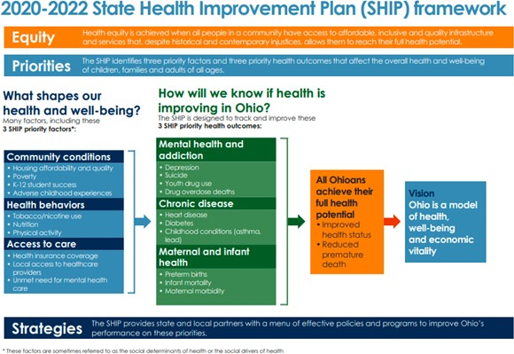

Prioritization
Representatives from Ashland County Health Department and University Hospitals Samaritan Medical Center formed the Ashland County Community Health Needs Assessment (CHNA) Steering Committee. The committee met regularly over several months to review secondary data and community feedback, suggest new partners to contribute to the prioritization process, and finally approve the finalized health needs. The steering committee engaged with Ashland County community partners throughout the assessment process. Representing a variety of sectors including academia, education, healthcare, transportation, social services, as well as the aging population and those with disabilities, these organizations play key roles in optimizing the community’s health.

Pictured below is a timeline outlining key collaborative meetings with stakeholders, subject matter experts, and valued organizations. These joint sessions and feedback opportunities allowed true alignment at the beginning phases of this work and delivered key components to the working plans for the aligned health needs.
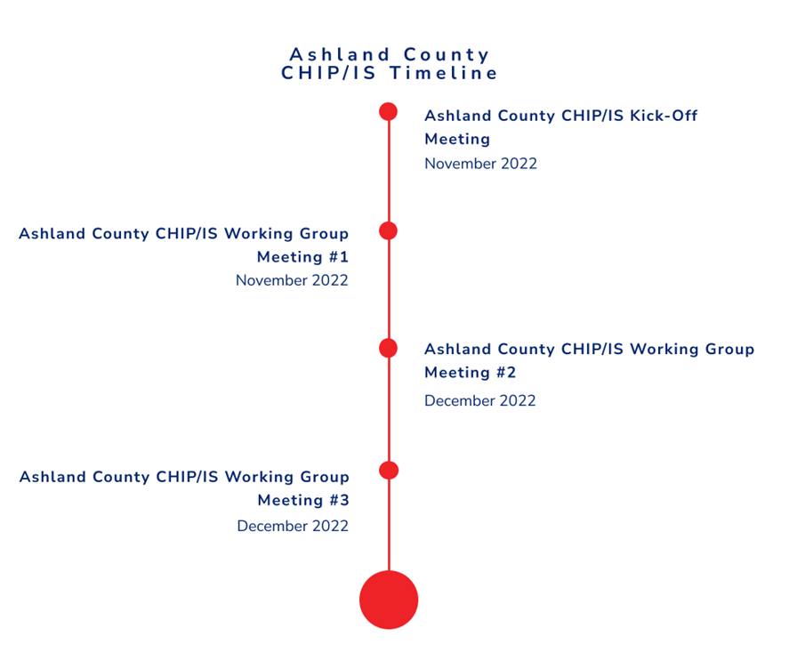

Ashland County Prioritized Health Needs

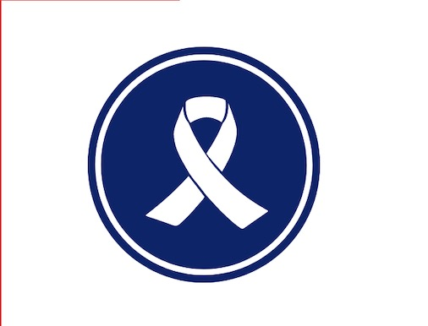
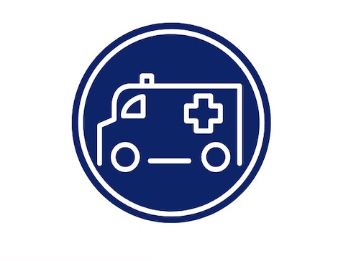
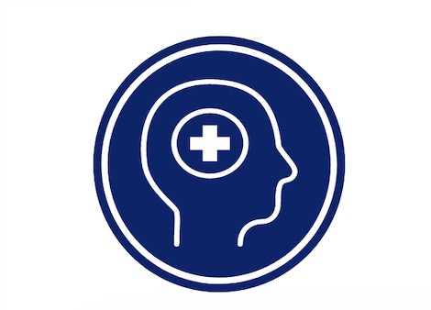

Cancer
Cancer is a significant health concern in Ashland County and across the United States, with significant impacts on individuals, families, and communities. Cancer affects people of all ages, races, and socioeconomic backgrounds, and can be caused by a variety of factors, including genetic predisposition, environmental exposures, and lifestyle choices.

Access To Healthcare
Accessible and affordable healthcare is a critical issue in Ashland County, as many residents struggle to access healthcare services. The CHIP/IS will work to improve access to healthcare by expanding health clinics, increasing outreach to underserved populations, and promoting health insurance enrollment.

Behavioral Health (Mental Health & Substance Use and Misuse
Behavioral health, mental health, and substance use, and misuse are critical health needs in Ashland County that require prioritization in the Community Health Improvement Plan. These issues affect individuals, families, and communities and can have significant impacts on overall health and well-being.

Next Steps & Conclusion

Plans and reports are not only meant for monitoring and evaluating progress but also for future planning. The Community Health Improvement Plan/Implementation Strategy (CHIP/IS) is an ongoing and dynamic process that enables collaborative efforts to measure the impact and progress of initiatives over time.
Addressing the prioritized health needs of cancer, access to healthcare, and behavioral health, mental health and substance use/misuse in Ashland County is crucial for improving the overall health and well-being of the community at large. The CHIP/IS should have continued focus on expanding healthcare access, increasing outreach to underserved populations, and promoting health insurance enrollment to ensure that residents have access to the necessary services and resources to prevent and manage these health issues.
Collaboration between healthcare systems and community-based organizations addressing social needs, along with future planning workshops, can help the collaborative toward the improvement of community health. The enhancement of care coordination can alleviate the burden on families in the community, lower costs, and improve equitable access to resources and services. Bridging vulnerable populations with community resources for unaddressed social needs, including mental and behavioral health, cancer, and affordable healthcare, work to diminish health and wellness obstacles and consequently result in better overall health outcomes.
Next steps for addressing these prioritized health needs include continued partnerships with local healthcare providers and community organizations, conducting targeted educational campaigns to raise awareness about the importance of prevention and early detection, and engaging community members in identifying and implementing effective strategies for improving health outcomes. Ongoing monitoring and evaluation of progress and outcomes will also be essential to ensure that efforts are effective and sustainable over time. By working together to address these critical health needs, Ashland County can promote a healthier, more equitable community for all residents.

Such valuable work couldn't move forward without the contributions of the people who worked tirelessly on community improvement efforts. Ashland County Health Department and University Hospitals Samaritan Medical Center wish to express their deep gratitude for the participation of a committed group of local partners and external stakeholders. Their invaluable contributions of time and expertise were instrumental in guiding the development of the CHIP/IS.
Acknowledgements

Over the course of several months, the committee convened regularly to examine secondary data and community input, propose new partners for the prioritization process, and endorse the finalized health needs, progressing into the improvement planning and strategy process.

Below, is a listing of those committed to these collaborative efforts and planning work:

·Appleseed Community Mental Health Center
·Ashland City Government
·Ashland City Schools
·Ashland County Board of Health
·Ashland County Chamber of Commerce
·Ashland County Council on Aging
·Ashland County Council on Alcoholism and Drug Abuse
·Ashland County EMA
·Ashland County Family and Children First Council
·Ashland County Job & Family Services
·Ashland Fire
·Ashland Parenting Plus
·Ashland University
·Catholic Charities Ashland
·Kroc Center/Salvation Army
·Loudonville- Perrysville Schools
·Mental Health Recovery Board
·Ohio Highway Patrol

We thank you for your continued support in our efforts to contribute to this valuable work.

* PLEASE NOTE THE CHIP IS A LIVING DOCUMENT ADAPTED IN RESPONSE TO EVERCHANGING CITIZENS, COMMUNITY AND STAKEHOLDER NEEDS. ANY LIST( S) OF PARTNERS INCLUDED IS NOT EXHAUSTIVE. THE COLLABORATIVE WELCOMES ANY ORGANIZATIONS AND STAKEHOLDERS INVOLVED IN PRIORITY- CENTERED WORK TO JOIN OUR EFFORTS.

Appendix: Work Plan

The following pages include the work plan for the county to work toward achieving better health outcomes for members of the Ashland community. This plan includes data points, goals, objectives, and actions that will be implemented in the next three years. The community engagement on this plan is invaluable. Ashland County Health Department will serve as the lead in ensuring all agencies are working toward the completion of the action steps. ACHD will also track the progress and data trends as we engage in the work of the Community Health Improvement Plan. Any questions or comments concerning this plan are welcomed. To submit comments, please visit the Ashland County Health Department website at www.ashlandhealth.com and use the “Contact Us” form.

CHNA Priority 1: Cancer

Goal 1: Reduce colorectal cancer death rates.
Goal 2: Reduce colorectal cancer incidence rates.
Goal 3: Reduce lung and bronchus cancer rates through the decreased use of tobacco, tobacco products, and vaping.
Community Level Indicators
Adults with Cancer  Colorectal Cancer Incidence Rate | Age-Adjusted Death Rate due to Colorectal Cancer  Cancer: Medicare Population

Strategy 1: Collaborate with providers and community partners on a variety of community outreach events targeted to cancer education and the value of cancer screenings.
Objective 1: Reduce the age-adjusted death rate due to cancer from 168.4 deaths per 100,000 by 5%.
Activities: | Year 1 | Year 2 | Year 3
Research County/Polk/Nova demographics and access to testing | X
Target education to Polk and Nova areas regarding screening and access to testing |  | X
Partner with UH for testing educational campaign |  |  | X
Baseline measure: CHNA 2022 & Health Northeast Ohio:
Colon Cancer Screening: Countywide 63.6%; Nova 59.8%; Polk 59.9%
Colorectal Cancer Incidence Rate: 50.6 per 100,000
CHR 23.6% 2019 Lung and Bronchus Cancer Incidence Rate: 62.4 per 100,000
Anticipated measurable outcome(s) based on current trends:
# of educational sessions/events
Increase the percentage of screenings by 10%
Reduce deaths from colorectal cancer by early detection
Impact current upward trend of cancer rates
Indicator(s) used to measure outcomes and data source: CHNA 2022 & Health Northeast Ohio:
Colorectal death rates indicators; colon cancer screenings colorectal cancer incident rates
Responsible Partners:
ACHD
UH Samaritan Medical Center
Community Partners:
UH Samaritan and PCP providers
UH, ACCADA, School districts
Ashland County Public Health Department, UH Seidman Cancer Center
Ashland County Cancer Association

Specific opportunities to address policy, equity and/or access:
The northern part of the county ranks lower in the county overall (Polk and Nova). Target those areas along with the whole county.
Target population(s): Polk and Nova residents (according to the vulnerability index), Senior citizens, Amish community.

Goal 1: Reduce colorectal cancer death rates.
Goal 2: Reduce colorectal cancer incidence rates.
Goal 3: Reduce lung and bronchus cancer rates through the decreased use of tobacco, tobacco products, and vaping.
Community Level Indicators
Adults with Cancer  Colorectal Cancer Incidence Rate | Age-Adjusted Death Rate due to Colorectal Cancer  Cancer: Medicare Population

Strategy 1: Collaborate with providers and community partners on a variety of community outreach events targeted to cancer education and the value of cancer screenings.
Objective 2: Reduce the percentage rate of adults who smoke from 23.6%.
Activities: | Year 1 | Year 2 | Year 3
Coordinate with UH on smoking cessation program | X
Increase social media education on effects of smoking and vaping | X | X
Target secondhand smoke campaign to pregnant mothers and new mothers |  | X | X
Work with ACCADA to target educational programming in the local schools especially related to vaping. | X | X | X
Baseline measure:
Adults who smoke: 23.6%
Adults who use e-cigarettes: 2.7%
Adults who used smokeless tobacco: 2.9%
Adults who used e-cig in past 30 days 3.3%
Mothers who smoked during pregnancy 12.7% (2020)
Anticipated measurable outcome(s) based on current trends:
# of educational sessions/events
Impact current upward trend of cancer rates
Indicator(s) used to measure outcomes and data source:
CHR on Adults who Smoke; adults who used e-cig in past 30 days; mothers who smoked during pregnancy
Responsible Partners:
ACHD
UH Samaritan Medical Center
Community Partners:
UH Samaritan and PCP providers
UH, ACCADA, School districts
Ashland County Public Health Department, UH Seidman Cancer Center
Ashland County Cancer Association
Specific opportunities to address policy, equity and/or access:
The northern part of the county ranks lower in the county overall (Polk and Nova). Target those areas along with the whole county for colorectal cancer rates
Target population(s): Adults, high school students, Polk and Nova residents, senior citizens, Amish Community.

Goal 1: Reduce colorectal cancer death rates.
Goal 2: Reduce colorectal cancer incidence rates.
Goal 3: Reduce lung and bronchus cancer rates through the decreased use of tobacco, tobacco products, and vaping.
Community Level Indicators
Adults with Cancer  Colorectal Cancer Incidence Rate | Age-Adjusted Death Rate due to Colorectal Cancer  Cancer: Medicare Population

Strategy 1: Collaborate with providers and community partners on a variety of community outreach events targeted to cancer education and the value of cancer screenings.
Objective 3: Host at least 2 training/educational opportunities
Activities: | Year 1 | Year 2 | Year 3
Host two live cancer education events including screenings; monitor number screened and number of referrals; evaluate outcomes by surveying participants for increase in knowledge | X
Increase participation by 10%; demonstrate increase in knowledge through surveys |  | X
Collaborate with community partners to develop strategy for mobile screening event |  |  | X
Baseline measure:
Demonstration of increase in knowledge
Anticipated measurable outcome(s) based on current trends:
Year-to-Year Measure: # of educational sessions/events
Indicator(s) used to measure outcomes and data source:
Cervical cancer screening, colon cancer screening, mammogram past 2 years, adults with routine checkups. HNEO rates
Responsible Partners:
ACHD
UH Samaritan Medical Center
Community Partners:
UH Samaritan and PCP providers
UH, ACCADA, School districts
Ashland County Public Health Department, UH Seidman Cancer Center
Ashland County Cancer Association
Specific opportunities to address policy, equity and/or access:
The northern part of the county ranks lower in the county overall (Polk and Nova). Target those areas along with the whole county.
Target population(s): Polk and Nova residents, Amish, Senior citizens.

CHNA Priority 2: Access to Healthcare

Goal 1: Increase access to care
Community Level Indicators
Primary Care Provider Rate  Adults who have had a Routine Checkup  Clinical Care Ranking | Adults who Visited a Dentist  Consumer Expenditures: Prescription and Non-Prescription Drugs

Strategy 1: Focusing on telehealth and usage by our older population, develop a framework to provide live group education events and 1-on-1 training to promote telehealth as an option for routine check-ups.
Objective 1: By December 2023 host at least two community outreach events that focus on the benefits of using telehealth as an option to complete a routine check-up.
Activities: | Year 1 | Year 2 | Year 3
Identify community partners to coordinate resources to offer technology education/demonstration of telehealth at least two locations. Hold at least two live events. | X
Establish a resource pool to offer additional 1:1 telehealth technology training and train twenty-five community members. Host two live group community outreach events. |  | X
Host two live educational events at two new/different locations. |  |  | X
Opportunity: Managed Care/Medicaid-emphasis on Medical Home/PCP for increase access to health and healthcare. CareSource, Molina, AmeriHealth, etc.
Baseline measure: CHNA 2022 & Health Northeast Ohio:
Adults who have had a routine checkup 76.3%
Adults without health insurance 12.3%
Adults who access medical services and information through the internet 32.4%
Anticipated measurable outcome(s) based on current trends:
Increase number of telehealth appointments
Increase percentage of adults who have had a routine check-up
Indicator(s) used to measure outcomes and data source: CHNA 2022 & Health Northeast Ohio:
Percentage of adults who have had a routine check-up (State Rate XX.X% 2019); number of telehealth appointments in primary care practices (Hospital System data).
Health Northeast Ohio
Responsible Partners:
UH Samaritan Medical Center
Community Partners:
Ashland Christian Health
Third Street Clinic (reviving medical and dental in Ashland)
Specific opportunities to address policy, equity and/or access:
Target population(s): Senior citizens, those without insurance, Amish community.

Goal 1: Increase access to care
Community Level Indicators
Primary Care Provider Rate  Adults who have had a Routine Checkup  Clinical Care Ranking | Adults who Visited a Dentist  Consumer Expenditures: Prescription and Non-Prescription Drugs

Strategy 1: Focusing on telehealth and usage by our older population, develop a framework to provide live group education events and 1-on-1 training to promote telehealth as an option for routine check-ups.
Objective 2: Provide a series of health education promotions on routine checkups and of free or low-cost options in the community.
Activities: | Year 1 | Year 2 | Year 3
Design an educational plan for social media on routine checkups. | X
Establish a resource guide of free or low-cost medical and dental services in Ashland County and disseminate to local partners and community members. Reevaluate and update the list every year. | X | X | X
Run the social media plan and measure results. |  | X | X
Build upon Amish Health and Safety by offering routine screenings for blood pressure, diabetes detection, and cholesterol. | X | X | X
Baseline measure: CHNA 2022 & Health Northeast Ohio:
Cervical Cancer Screening 80.5%, Colon Cancer screening, 69.7% mammograms is past 2 years 70.6%, mammogram screening: Medicare Population 51%, adults who have routine checkup 76.3%; Adults 65+ who received recommended preventative services: Females 35.9%; Males 38%;
Anticipated measurable outcome(s) based on current trends: Increase the number of screenings and routine checkups

Indicator(s) used to measure outcomes and data source: Healthy NEO: Cervical Cancer Screening 80.5%, Colon Cancer screening, 69.7% mammograms is past 2 years 70.6%, mammogram screening: Medicare Population 51%, adults who have routine checkup 76.3%; Adults 65+ who received recommended preventative services: Females 35.9%; Males 38%;
Responsible Partners:
ACHD
Community Partners:
Ashland Christian Health
Third Street Clinic (reviving medical and dental in Ashland)
Specific opportunities to address policy, equity and/or access: promote free or low cost services available in the community for those with no insurance or the underinsured.
Target population(s): 65+, underinsured, uninsured, Amish, children eligible for Medicaid services

CHNA Priority 3: Behavioral Health—Mental Health

Goal 1: Reduce the number of suicides and those suffering from Depression in Ashland County.
Community Level Indicators
Poor Mental Health: +14 Days  Poor Mental Health: Average Number of Days  Age-Adjusted Death Rate due to Suicide | Self-Reported General Health Assessment: Good or Better  Adults Ever Diagnosed with Depression

Strategy 1: To build a community awareness campaign; providing community awareness and education associated with stigma and its impacts on individuals, families, etc. accessing behavioral health services.
Objective 1: Reduce the number of adults ever diagnosed with depression
Activities: | Year 1 | Year 2 | Year 3
To engage in a community awareness campaign. Content = Reducing Stigma associated to mental health | X
Evaluate the educational landscape for (preventing duplication of services) -Mental Health, BH Programs, Suicide Prevention, Depression, Grief | X
Analysis gaps and develop action plan to address (better coordination and support)  Develop sustained partnership between mental health recovery board with Ashland co. public health |  | X
Evaluate ongoing need/community use/report out (close the loop)-convening partners |  |  | X
Baseline measure:
22.1% adults were ever diagnosed with depression
Anticipated measurable outcome(s) based on current trends:
Indicator(s) used to measure outcomes and data source: CHNA 2022 & Health Northeast Ohio:
# of suicides in Ashland County
Suicide deaths: Regular Matrix reporting by the Board’s contract partners and communication with other agency partners (e.g., AU, Coroner, Health Dept.)
Healthy Northeast Ohio
MHRB
Responsible Partners:
MHRB of Ashland County
Health Department, ADAMHS Board, ACCADA, and Appleseed
ACHD
Community Partners:
ACCADA, Appleseed Mental Health, Catholic Charities, Ashland Police and Sheriff’s Office (QRT)
CCS, FCFC, Substance Use Advisory Committee
Council on Aging, MHRB, and other partners to advertise the events and promote the grief training
Possible collaboration with any local social service agency with mission surrounding mental health, substance abuse, or desire to assist older population
Ashland University, Appleseed Community Mental Health Center, Coroner’s Office, Health Department, Ashland County Suicide Prevention Coalition.
Specific opportunities to address policy, equity and/or access: promote the services that are available in the county including self-pay, insured, and uninsured programs.
Target population(s): incarcerated ready to be released; youth, adults, college students, those 65+

Goal 1: Reduce the number of suicides and those suffering from Depression in Ashland County.
Community Level Indicators
Poor Mental Health: +14 Days  Poor Mental Health: Average Number of Days  Age-Adjusted Death Rate due to Suicide | Self-Reported General Health Assessment: Good or Better  Adults Ever Diagnosed with Depression

Strategy 2: Reduce the impact of mental health stress or depression due to grief.
Objective 1: Host one cohort training for grief recovery training (informational session + train the trainer) by 2025
Activities: | Year 1 | Year 2 | Year 3
Spring 2023 hold a grief awareness seminar to find those interested in participating in the Grief Recovery Method Seminar (ACHD) | X
Spring 2023/2034 hold Grief Recovery Method workshops with clients (ACHD) | X | X | X
Baseline measure: currently zero grief recovery on the Grief Recovery Method.
Anticipated measurable outcome(s) based on current trends: number of people attending grief recovery training – pre and post testing related to understanding grief.
Indicator(s) used to measure outcomes and data source:
Pre and post survey on grief and depression
Responsible Partners:
ACHD
Community Partners:
UH Samaritan Medical Center
ACCADA, Appleseed Mental Health, Catholic Charities, Ashland Police and Sheriff’s Office (QRT)
CCS, FCFC, Substance Use Advisory Committee
Council on Aging, MHRB, and other partners to advertise the events and promote the grief training
Possible collaboration with any local social service agency with a mission surrounding mental health, substance abuse, or desire to assist the older population
Ashland University, Appleseed Community Mental Health Center, Coroner’s Office, Health Department, Ashland County Suicide Prevention Coalition.
Specific opportunities to address policy, equity and/or access: Make available to all regardless of ability to pay.
Target population(s): anyone who wants to address grief and unresolved grief.

Goal 1: Reduce the number of suicides and those suffering from Depression in Ashland County.
Community Level Indicators
Poor Mental Health: +14 Days  Poor Mental Health: Average Number of Days  Age-Adjusted Death Rate due to Suicide | Self-Reported General Health Assessment: Good or Better  Adults Ever Diagnosed with Depression

Strategy 3: Increase Suicide Prevention Trainings in the County.
Objective 1: By the end of SFY 2026, Increase QPR Suicide Prevention Trainings by 50% over baseline.
Activities: | Year 1 | Year 2 | Year 3
Utilize the Ashland County Suicide Prevention Coalition to increase the number of organizations and individuals trained in QPR | X | X | X
Collaborate with Ashland University to increase on-campus QPR training to faculty, staff, and students | X | X | X
Collaborate with local school systems via the School-Community Liaison Program to increase QPR to middle and high school-age students, teachers, and administrators | X | X | X
Baseline measure:
SFY 2022 saw @500 persons trained in QPR
Anticipated measurable outcome(s) based on current trends: Reduction in the number of suicides in the county.
Indicator(s) used to measure outcomes and data source: Suicide rates; Annual Suicide reviews.
Responsible Partners:
MHRB of Ashland County
Health Department, ADAMHS Board, ACCADA, and Appleseed
ACHD
Community Partners:
UH Samaritan Medical Center
ACCADA, Appleseed Mental Health, Catholic Charities, Ashland Police and Sheriff’s Office (QRT)
CCS, FCFC, Substance Use Advisory Committee
Council on Aging, MHRB, and other partners to advertise the events and promote the grief training
Possible collaboration with any local social service agency with mission surrounding mental health, substance abuse, or desire to assist older population
Ashland University, Appleseed Community Mental Health Center, Coroner’s Office, Health Department, Ashland County Suicide Prevention Coalition.
Specific opportunities to address policy, equity and/or access: increase trained people to provide services to anyone who needs them.
Target population(s): schools, university, teachers

CHNA Priority 3: Behavioral Health—Substance Use/Misuse

Goal 1: Reduce deaths caused by drug overdose (both intentional and non-intentional)
Goal 2: Evaluate landscape of substance use/misuse in the county
Goal 3: Reduce prescription drug use
Goal 4: Reduce the number of alcohol-impaired driving deaths
Community Level Indicators
Adults who Binge Drink  Alcohol-Impaired Driving Deaths | Adults who Drink Excessively  Consumer Expenditures: Tobacco and Legal Marijuana

Strategy 1: Decrease prescription medication abuse (Increase access to methods of safe disposal of prescription drugs for the community)
Objective 1: Reduce substance use and misuse in the community
Activities: | Year 1 | Year 2 | Year 3
2 Take Back Drugs events; distribute DisposeRX at 2 community outreach events. | X | X | X
Develop more community awareness of the Dispose RX, & Community Events (hospitals). | X | X | X
Baseline measure:
Emergency Department Visits for Suspected drug overdose
2022 Q1 – 19
2022 Q2 – 34
2022 Q3 – 29
2022 Q4 – 28
Total 2022 – 110
Anticipated measurable outcome(s) based on current trends:
# of New Community Events
Increase poundage of drugs taken back by 5%; (drug take back)
# of ED visits for a drug overdose.
Indicator(s) used to measure outcomes and data source:
OHO Emergency Department Visits for Suspected Drug Overdose
Law enforcement divisions
Responsible Partners:
UH Samaritan Medical Center
MHRB of Ashland County
Health Department, ADAMHS Board, ACCADA, and Appleseed
ACHD, University Hospital
Community Partners:
ACCADA, Appleseed Mental Health, Catholic Charities, Ashland Police and Sheriff’s Office (QRT)
CCS, FCFC, Substance Use Advisory Committee
Council on Aging, MHRB
Possible collaboration with any local social service agency with mission surrounding mental health, substance abuse, cancer or desire to assist older population
Ashland University, Appleseed Community Mental Health Center, Coroner’s Office, Health Department
Specific opportunities to address policy, equity and/or access: None
Target population(s): Elderly, all citizens

Goal 1: Reduce deaths caused by drug overdose (both intentional and non-intentional)
Goal 2: Evaluate landscape of substance use/misuse in the county
Goal 3: Reduce prescription drug use
Goal 4: Reduce the number of alcohol-impaired driving deaths
Community Level Indicators
Adults who Binge Drink  Alcohol-Impaired Driving Deaths | Adults who Drink Excessively  Consumer Expenditures: Tobacco and Legal Marijuana

Strategy 2: Increase NARCAN and NaloxBox Distribution.
Objective 1: Reduce substance use and misuse in the community
Activities: | Year 1 | Year 2 | Year 3
Evaluate (environmental scan) of landscape of services/programs with NARCAN distribution | X
Ensure ACCADA, Appleseed, and the Health Department have a sufficient ongoing supply of NARCAN | X | X | X
Ensure the agencies and other partners promote the availability of NARCAN and NaloxBoxes | X | X | X
Regularly report the changes in NARCAN and NaloxBox distribution | X | X | X
Monitor the number of Overdose Deaths | X | X | X
Provide education through social media and other sources regarding drug use and abuse, physical and mental consequences, and legal consequences. | X | X | X
Baseline measure:
Death Rate due to Drug Poisoning 19.9 deaths per 100,000 (2018-2020)
Age-adjusted drug and opioid-involved overdose rate 24.6 deaths per 100,000 population (2018-2020)
Anticipated measurable outcome(s) based on current trends:
Reduce drug overdose deaths
# of Delivered Ads/Articles in local Gazette
# Digital and/or stationary billboard campaigns (Existing)
Keeping Ashland Healthy Podcast Series (Existing)
Indicator(s) used to measure outcomes and data source:
Overdose deaths: Regular Matrix reporting by the Board’s contract partners and communication with other agency partners (e.g., AU, Coroner, Health Dept.)
(Healthy NEO)
Responsible Partners:
MHRB of Ashland County
Health Department, ADAMHS Board, ACCADA, and Appleseed
ACHD
Community Partners:
ACCADA, Appleseed Mental Health, Catholic Charities, Ashland Police and Sheriff’s Office (QRT)
CCS, FCFC, Substance Use Advisory Committee
Council on Aging, MHRB
Possible collaboration with any local social service agency with mission surrounding mental health, substance abuse, cancer or desire to assist older population
Ashland University, Appleseed Community Mental Health Center, Coroner’s Office, Health Department
Specific opportunities to address policy, equity and/or access: Providing Narcan across the county.
Target population(s): Individuals, business, schools, university

Goal 1: Reduce deaths caused by drug overdose (both intentional and non-intentional)
Goal 2: Evaluate landscape of substance use/misuse in the county
Goal 3: Reduce prescription drug use
Goal 4: Reduce the number of alcohol-impaired driving deaths
Community Level Indicators
Adults who Binge Drink  Alcohol-Impaired Driving Deaths | Adults who Drink Excessively  Consumer Expenditures: Tobacco and Legal Marijuana

Strategy 3: Assure Ongoing Access to Local Medication Assisted Treatment (MAT) Programming.
Objective 1: Reduce substance use and misuse in the community
Activities: | Year 1 | Year 2 | Year 3
Evaluate and Ensure sufficient High-Fidelity MAT programming exists in the county. Communicate resources to the public | X | X | X
Ensure access is timely and the process is well communicated to the public. | X | X | X
Monitor the number of Overdose Deaths. | X | X | X
Baseline measure:
Approximately 50 persons received county MAT services in SFY 2022
MAT Reports to the MHRB
7 Overdose Deaths in CY 21
ACCADA semi-annual report.
ACHD SDO annual review
Anticipated measurable outcome(s) based on current trends:
Number of persons involved with County MAT programming increased; number of reported deaths due to overdose; number of ED visiting for drug overdose.
Indicator(s) used to measure outcomes and data source:
Overdose deaths: Regular Matrix reporting by the Board’s contract partners and communication with other agency partners (e.g., AU, Coroner, Health Dept.)
# Deaths due to accidents involving drugs or alcohol.
# ED visits for suspected drug overdose by county.
Responsible Partners:
MHRB of Ashland County
Health Department, ADAMHS Board, ACCADA, and Appleseed
ACHD
Community Partners:
ACCADA, Appleseed Mental Health, Catholic Charities, Ashland Police and Sheriff’s Office (QRT)
CCS, FCFC, Substance Use Advisory Committee
Council on Aging, MHRB
Possible collaboration with any local social service agency with mission surrounding mental health, substance abuse, cancer or desire to assist older population
Ashland University, Appleseed Community Mental Health Center, Coroner’s Office, Health Department
Specific opportunities to address policy, equity and/or access: More access to Narcan
Target population(s): drug users, teens, families

